1. Project Title: Kwik E-Kart

Group Name: Kwik E-Kart

Group Member Names:

Axel Yates

Paul Gerard

2. Project description: The end goal of what we plan to develop is a fully functioning shopping cart for business professionals who are transitioning their businesses to the internet. We are going to be creating this service by leveraging the power of Javascript, NodeJS, and other higher level languages as needed. Our product will be a tool for business owners to use that gives them the freedom to express their business with all of the power that the internet provides, without sacrificing security, swiftness, or expertise.

5. Meeting Minutes

Paul Gerard and Axel Yates are present at any mentioned meeting:

1. 9/9/2017 12:00 P.M. - 2:00 P.M.

Worked on first deliverable and related information

General project planning related to end goal functionality

Division of labor amongst group members

Technology stack used for this project.

2. 9/12/2017

Worked on presentation slides

Created the file directory for our project.

Individual Work (outside meetings):

1. 9/12/2017 12:00 P.M.-2:20PM:

Paul: Editing Report

Study course materials related to activity planning

Planning topics for discussion during meeting in and after class.

2. 9/13/2017 10:00AM - 12:45PM

Axel: Editing Report

Creating Gantt chart

Working on Presentation Slides

Uploading Gantt chart, Presentation Slides, and Deliverable 1 to Github.

6.

Gantt Chart (Also uploaded to Github Repository):

List of Official Deadlines/Milestones:  
9/13 - Deliver report 1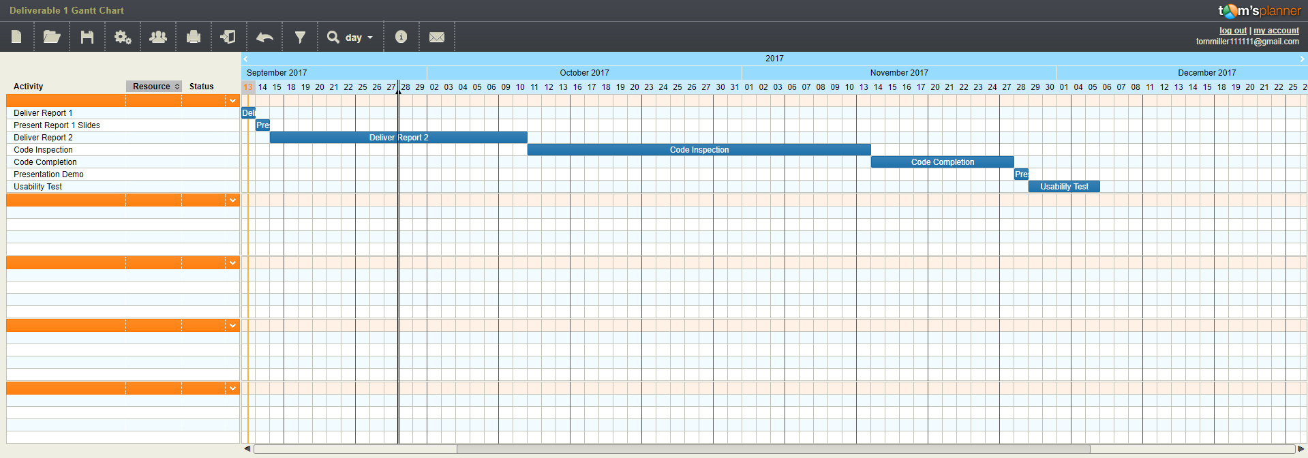

+Project description and title

+Directory structure document

+Milestones and timeline

+Meeting minutes

9/14 - Present report 1 slides

10/10 - deliver report 2  
 +Software requirements specification (SRS)

+UML design documents including class, sequence, and use case diagrams

+Test Plan

+Updated risk management, meeting minutes, and project roadmap

+Progress report on status of software.

+Member contribution table

11/13 - Code inspection

11/27 - Code Completion  
 - deliver report 3

+User manual for Kwik-E-Kart

+Instructions for compiling and running program and demo build

+Set of automated test cases

+List of successfully implemented features and limitations

+Meeting minutes

+Member contribution table

11/28 - Presentation/demo

12/5 - Usability test (by 3rd party outside group)

7. Risk Management:

Top 5 risks for our project:

1. Illness / Emergency - Due to the fact that there are only two of us. If one of us is incapacitated for an extended period of time due to any number of complications, it’ll put a very large workload on the other to make our set deadlines. This is our number one risk mainly due to the fact that as hard as you try, there may just not be any way around this.
   1. Contingency: Honestly, there is no real fix for this issue. In the unfortunate event that one of us falls ill or needs to take care of an emergency, the other will have to do their best. Specifically with the winter months coming up, sickness is bound to happen. Mitigating the illness when it props up is our primary focus
2. Lack of Effort - If one of us simply doesn’t put forth very much effort then it will fall on the shoulders of the other team member to pick up the slack and make sure we have a finished product by the deadline.
   1. Contingency: To fix this issue we will both get in agreement on what the other is supposed to finish by the specified times. Both of us are committed to the other to make sure that we put forth our best effort possible.
3. Out of Scope - If our project explodes out of the initial scope we set for it there could be cause for concern. While we are taking preventative measures ahead of time to make sure that this does not happen. We are planning for the unfortunate event that something pops up that neither of us saw coming.
   1. Contingency: To fix this issue we would scale back the project or change the end goals to better suit a more viable timeline. Along the same vein, we could also make sure that we do not try to make the project fancier or flashier than intended. What we mean by this is that if a few extra graphics would push us too close to the deadline, we would remove that from our workload.
4. Technical Difficulties - If, heaven forbid, our files get accidentally deleted or irreparably damaged, or we have our computers crash in the middle of work without it backing up we could be set back countless hours. This is mainly a risk if we let it slip, both Paul and I are good about consistently saving work.
   1. Contingency: To fix this issue, we will constantly back up our progress whenever we can and make sure that we aren’t putting ourselves at risk by having older / deprecated software or hardware. Also, having multiple backups running concurrently as well as having everything backed up to GitHub at certain times throughout the project will help us avoid this pitfall.
5. Only Two of Us - We briefly touched on this in issue 1 but it begs it’s own number. Since there are only two of us we have to make sure the scope is within bounds and no matter how we slice it, we’ll both end up having to do significantly more work than if there were twice as many more people.
   1. Contingency: There’s not really a fix for this other than trying to keep the scope within reason. Also, working as hard as we can to finish the best project possible.

8. Team Member Names:

Axel Yates:

Role: Axel’s role in this project is to make sure that the shopping cart on the website is connected through a secure socket layer. Along this same vein he is required to make sure that the customer will be leaving with peace of mind knowing that he has taken every measurable step to ensure his customers safety from common hacking attacks such as, Cross Site Scripting, Phishing, SQL Injections, DDoS Attacks, etc. Axel will also be in charge of making sure that the customer has their account, password, credit card information, and any other sensitive data stored with an airtight encryption that cannot be compromised by any rudimentary attack from a malicious individual.

Paul Gerard:

Role: Paul’s role in this project is to make sure that the customer has a beautiful user interface to navigate their website. With this in mind, Paul makes sure that the customer is not confused by the service we provide and has a great experience transitioning to the web, which can often be a scary process. When making the front end graphical user interface, Paul will have templates on our end to help guide the customer through the process, and also give the customer their own freedom of expression however they’d like.

Project Repository:

https://github.com/axelyates/Kwik-E-Kart

9. Member contribution table

|  |  |  |  |
| --- | --- | --- | --- |
| Member name | Contribution description | Overall Contribution (%) | Note  (if applicable) |
| Axel Yates | Back end | 100% | Doing an awesome job |
| Paul Gerard | Front end / GUI | 100% | Doing an awesome job |